**Page Navigation**

**How to use Page Navigation in Power BI?**

* Why we use Page Navigation?
* To Switch from one page to another page

Step 1: First Create one Button

To Create Button: Click on Insert Tab 🡪 Click on Button 🡪 and Choose Blank Button Option

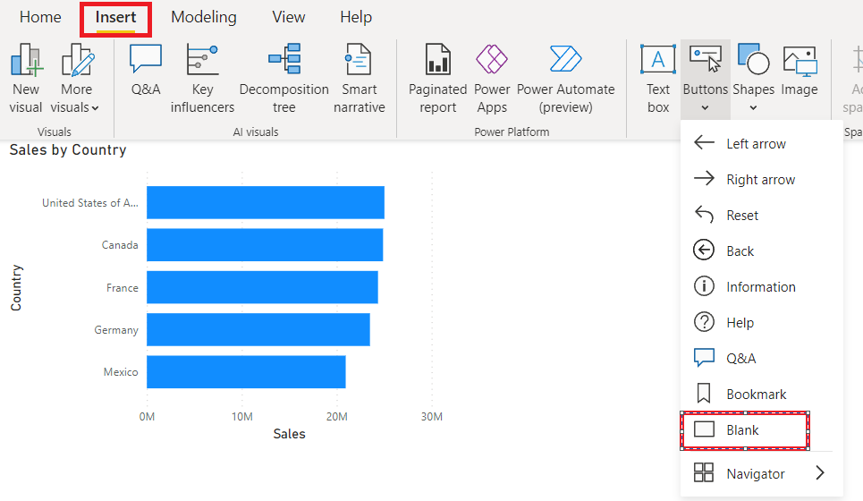

Step 2: After Creating Button 🡪 Under Format 🡪 Click on Style 🡪 ON Text option 🡪 And type button name as per your requirements.

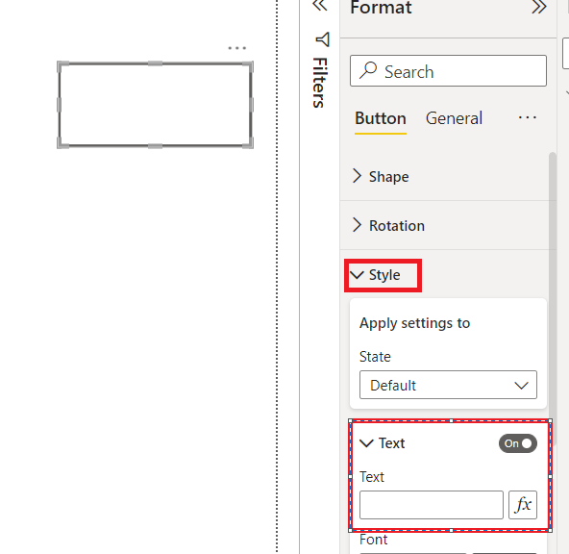

Step 3: ON Action Pane 🡪 Under Type Choose Page Navigation 🡪 Under Destination choose your Target page where you want to switch

